Title in Title Case: Subheading Included, No More Than Two Lines and Typically 15 Words in Total (Style: Article Title)
Name I. Surnameª, Name Surname^{b}, and Name I. Surname^{c} (Style: Authors)
ª Institution A, Country; ^{b} Institution B, Country; ^{c} Institution C, Country (Style: Author Affiliations)
Editors [LEAVE BLANK]
Section:
Senior Editor:
Associate Editor:
Publication
Submission: first date the paper is submitted to JUTLP
Revised: first date a submission is revised after review
Accepted:
Online First:
Published:
Copyright © by the authors, in its year of first publication. This publication is an open access publication under the Creative Commons Attribution CC BY-ND 4.0 license.

Abstract (Style: Heading Front Page)
JUTLP uses an unstructured single-paragraph abstract. The abstract should include a problem statement, any theoretical framework used, method, key findings, and implications. Avoid duplicating the information in abstract with statements in the practitioner notes, the two components should be complementary. The abstract should be no longer than lines 7 to 23 and a maximum of 250. The formatting and word limits have been carefully specified to ensure the front page of your article contains all summary information before the introduction begins on page 2. The first page is designed to maximise the potential for engagement with your work and thereby support you to make optimal impact with your publication. Where there are many authors and/or affiliations that need to be included on the front page, the abstract and practitioner notes may need to be a lower word/line count. For any advice, please contact the editor dealing with your submission. For guidance about writing abstracts see Dobbins et al. (2024). (Style: Front Page Text)

Practitioner Notes
- The practitioner notes are 5 short statements which are summary points, action orientated and align your paper to impact in practice. (Style: Practitioner Notes)
- Each statement should be short and no more two lines of text each. Our template is designed to retain all the summary information on a single front page.
- A reader should be able to use the practitioner notes to determine their interest in your paper, so the notes are important for engagement with your paper.
- Example: When using digital technology for learning, practitioners are advised not to assume that any group or identity of student is going to be more of less confident than any other.
- Example: Research communities should champion high-quality peer review as an active force for advancing scholarship.

Keywords
Max. 5, 1 line, no abbreviations, i.e. artificial intelligence, curriculum design, leadership, belonging
When preparing your submission, use this template to correctly format your manuscript using the in-built styles. Delete the guidance notes and style notes before submission. Please ensure you retain the page break and meet the specified requirements of page 1 so that the Introduction heading appears directly on page 2 and the front-page content is contained within 1 page.
Note that converting from Word.dotx format to Google Docs or other software versions may disrupt or remove the applied styles. Please check before you submit that your formatting and styles are correct.
Submission to JUTLP requires two versions of this template – one with all elements retained (the IDENTIFIED version) and one with all identifying information (author names, affiliations, names in the CRediT list, and any other identifying information in the text) removed (the DEIDENTIFIED version). More publication guidance resources can be found at https://open-publishing.org/journals/index.php/jutlp/guidance.
JUTLP is a diamond open access journal that does not charge authors or readers any fees. All editors are volunteers. Your adherence to this template supports our editors to publish consistent articles in a streamlined and collaborative way. Thank you.

Introduction (Style: Heading 1)
The body of your manuscript should use 11pt, left justified, Arial font with 1.15 line-spacing and should not be indented. Expected main section headings are Introduction, Literature, Method, Results, Discussion, and Conclusions. Using the ‘normal’ style of this template will ensure this formatting is correctly applied. We have included the usually expected headings (i.e. Introduction, Literature, Method, etc.) but there may be other structures that would be more appropriate for your paper. Where you have used a different structure, explain why in your submission cover letter.
The introduction should establish a clear learning and teaching practice problem and explain why it matters in the context of current practice. Authors should outline the specific issue, show how it is understood in the existing literature, and identify the gap or challenge the study addresses. This problem statement should provide a logical foundation for the research questions, which should follow directly from the aspects of practice the study aims to explore or improve.
Research questions are an expectation for JUTLP and should be clearly stated at the end of the introduction, showing how they arise from the learning and teaching practice problem. For guidance on developing and using research questions, see Purvis et al. (2024) and the IDEA ARC model (Figure 1) of research question development and use. After stating your research questions, include a brief explanation how the structure of the paper responds to them. The paper by Purvis et al. (2024) also offers several examples of research questions and can support you in writing clear and effective questions.
Figure 1 (Style: Figure Number)
The IDEA-ARC Model (Reproduced with permission from Purvis et al., 2024) (Style: Figure Title)
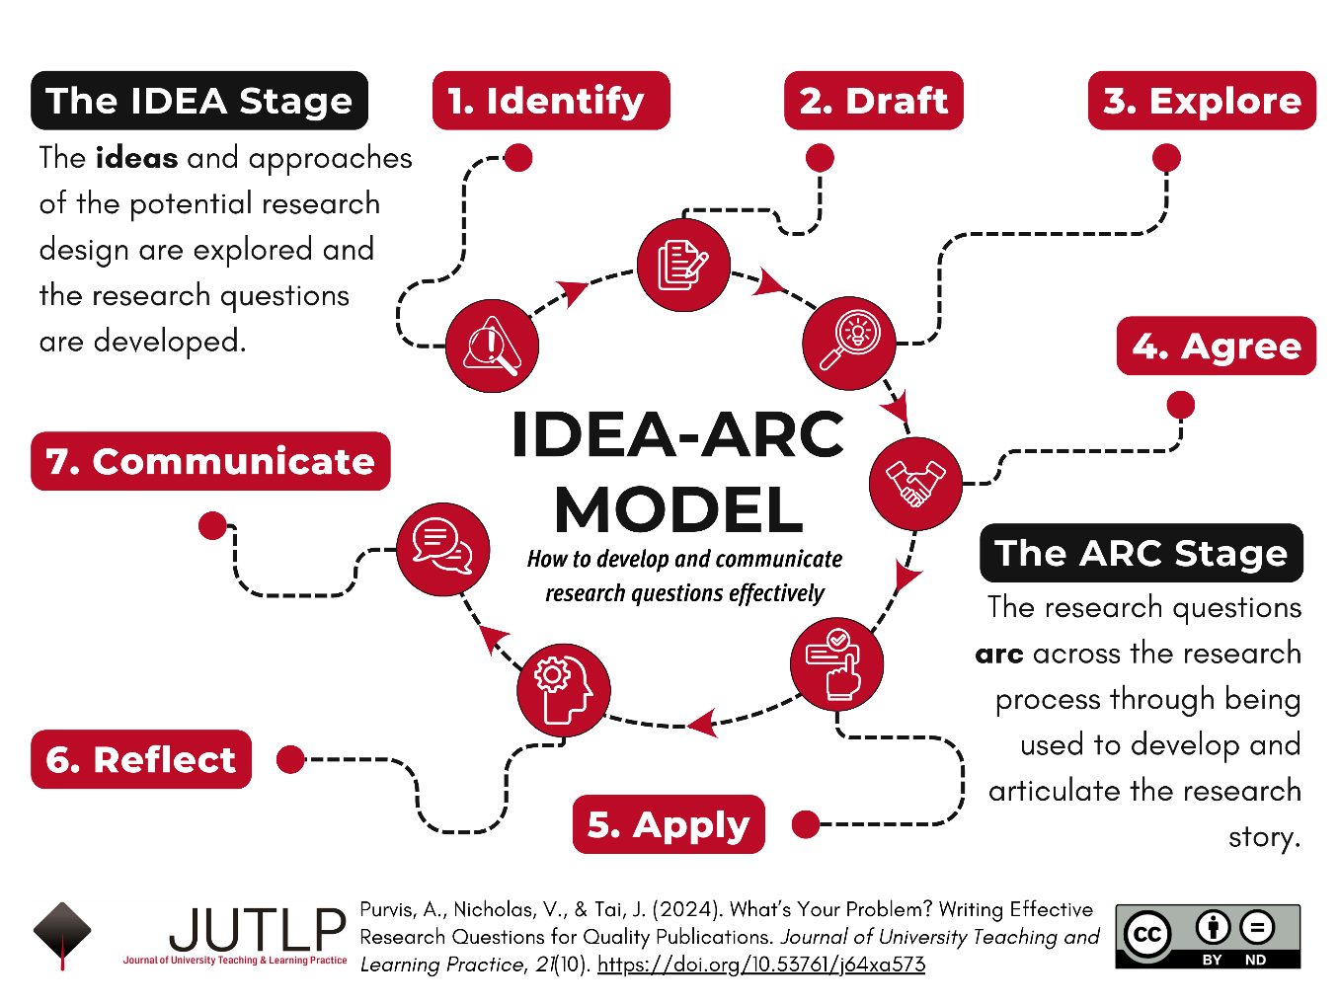
Ensure that any figure you include is necessary, legible, and clear. Your editors will support pagination and formatting of figures and tables to ensure best presentation.

Literature
Authors should use this section to situate their study within the existing body of scholarship and relevant theoretical or conceptual frameworks to show how their work builds on, extends, or challenges what is already known. This involves identifying the key debates, concepts, and empirical findings that shape current understanding of the topic and explaining how these inform the study’s focus and design. The aim is not to provide an exhaustive review, but to present a clear, critical, and coherent account of the most relevant literature, highlighting where the study offers a contribution or addresses a gap.

Subheading
Where they add to the structure and only where they provide clarity, you may use subheadings in any section. Quotes less than 40 words should have quotation marks around the words be incorporated in-line with a paragraph without additional formatting, such as “quotation here with up to 40 words” (Author, 2025).
Quotes longer than 40 words should be formatted as block quotations using the Quote style. Refer to APA guidance for further details about quotes. Common errors with quotes are the use of italics for formatting and the use of quotation marks in block quotes. Author name and page number would be included at the end such as this. (Author & Author, 2025, p. 123) (Style: Quote)

Subheading in Title Case
Subheadings should be used only when they genuinely improve the structure or clarity of the paper. They are not an expected part of the standard structure. Level 3 headings are rarely necessary and should be avoided, as they can interrupt the flow of the text and make the paper harder to read.

Method
The expected sub-headings are provided to help you produce a high‑quality manuscript. If you choose not to use them, please give a clear and robust rationale in your cover letter. A strong methods section should be clear and concise and should provide enough detail for readers to replicate the study effectively in future research.

Research Design
Begin by explaining how you met the expected ethical standards in Purvis and Crawford (2024). The Journal expects you to state your approach to ethics here and include a confirmatory ethics statement in the acknowledgements. Provide a brief, transparent account of the research design. State whether the study uses a qualitative, quantitative, or mixed‑methods approach and explain why this is appropriate for the research questions. Outline the key features of the design, such as timing, structure, and any comparative or longitudinal elements. This section should give readers a clear understanding of how the study was planned and how design decisions shaped the data.

Participants
Provide a clear description of the participants included in the study: how many took part, how they were recruited, and any inclusion or exclusion criteria that shaped the sample. Relevant demographic or contextual information should be reported where it is necessary to understand the study. Note any attrition or missing data and explain how these issues were handled. The description should be sufficiently transparent to allow readers to assess who the findings apply to and how the sample may influence interpretation of the results.

Measures
Explain how the key concepts in the study were assessed. Identify each measure, outline what it captures, and demonstrate relevance to the research questions. For established instruments, note their purpose and cite the original sources. For adapted or new measures, summarise how they were developed or selected and provide enough detail for replication. Briefly describe any scoring procedures or scale properties so readers understand how the variables were operationalised.

Procedure
Describe clearly how the data were gathered, including where and when data collection took place, the tools or instruments employed, and the steps taken to ensure consistency and quality. Any instructions given to participants, modes of delivery, or technological platforms used should be briefly outlined. If changes occurred during data collection, these should be noted and justified. The aim is to provide enough detail for readers to understand how the data were obtained, to demonstrate the robustness of the data collection, and to enable replication in future research.

Analysis
Authors should describe the analytical approach used, outline the steps taken in the analysis, and clearly show the approach is appropriate for the research questions and data type. Any software, coding frameworks, statistical tests, or interpretive strategies should be named and briefly explained. The description should provide enough detail for readers to understand how the results have been generated and support how further interpretations and conclusions were reached.
We strongly recommend that all qualitative research papers include a reflexivity or positionality paragraph within this subsection. Reflexivity refers to the process through which researchers acknowledge and critically consider the ways their own identities, backgrounds, assumptions and relationships to the research context may shape the study. A positionality statement makes these influences explicit. Including such a paragraph strengthens the trustworthiness, transparency and ethical clarity of the work by helping readers understand how the research was framed, conducted and interpreted.
Although reflexivity is most associated with qualitative methodologies, authors of quantitative research papers should also consider including a brief reflexivity or positionality statement. All research involves decisions about design, sampling, measurement, analysis and interpretation. These decisions are shaped by the researcher’s disciplinary background, values, theoretical commitments and lived experience. A short statement can therefore help readers to understand the intellectual and practical context in which the research was undertaken. Such statements should be concise, focused and written in plain language. They are not intended to centre the researcher, but to provide transparency and support the reader in evaluating the credibility and context of the work.
When adding tables and figures into your manuscript, please ensure that you use the appropriate styles and refer to tables either in parentheses (Table 1) or in narrative style. Where tables or figures are split across a page, we will attend to that formatting during the final stages following acceptance of your paper.
Table 1 (Style: Table Number)
Add Your Table Title Here (Style: Table Title)
Column 1 Heading | Column 2 Heading | Column 3 Heading | Column 4 Heading
Row 1 Heading  (Style: Table Emphasis) | Tables are normally formatted without vertical lines, and often with only horizontal lines at the header row and last row. (Style: Table Text)
Row 2 Heading |  | Specific formatting can vary, this style is most common. Tidy, consistent and clear presentation is the priority. | If you can see dashed lines around each box – you are viewing the table guidelines. These are non-printing and will not be visible in the final PDF.
Row 3 Heading
Final Row Heading | A bottom border for the last row
Note. Table notes can be added below if needed. Not all tables include table notes. Figures may also have notes added below where needed.

Results
Ensure that you include both a results section and a discussion section. JUTLP does not allow combined results and discussion sections. The results section should present the findings clearly and objectively, without interpretation. Report the outcomes that directly address the research questions and organise them in a logical sequence, using tables or figures only where they add clarity. Describe all results in plain language, with enough detail for readers to understand what was found, but do not repeat information already shown in tables or figures. Any interpretation or explanation belongs in the discussion section.
Refer to each table or figure in the text and place it close to its first mention. Final layout adjustments will be made at copy editing. Where possible, avoid tables that split across pages and avoid leaving more than a quarter of a page blank. Figure 2 provides an example of a PRISMA flow diagram for systematic reviews. Its presentation illustrates the expected numbering and titling of figures. Ensure that any figure you include is necessary, legible, and clear.
Figure 2 (Style: Figure Number)
PRISMA Results (Style: Figure Title)
Records identified through searching the JUTLP database:
(n = 147)
Records removed before screening:
Duplicate records removed
(n = 0)
Records screened
(n = 147)
Records excluded
(n = 114)
Full-text articles retrieved and screened
(n = 33)
Full-text articles assessed for eligibility
(n = 17)
Full texts excluded:
- Social media or online networking was not featured
(n = 2)
- Social media use was incidental (n = 2)
- Paper was not original research (n=1)
- Social media use was not related to learning (n = 1)
Studies included in review
(n = 11)
Identification of studies
Identification
Screening

Included

Discussion
The discussion should open by revisiting the research questions and summarising the key findings. These questions can be used to structure the discussion, and subheadings may help show how the results address each one (Purvis et al., 2024). For example, the question “What are students’ expectations and understanding of inclusive practice?” could become the subheading “Expectations and Understanding of Inclusive Practice”. Whatever structure you choose, the discussion must focus on interpreting and analysing the results in relation to the practice problem and relevant literature, rather than repeating descriptive detail.
The section should include the required subheadings: Practical Implications, Theoretical Implications, and Limitations and Future Research.

Practical Implications

Authors should explain the relevance of their findings for real‑world practice. This includes identifying the groups who can act on the results, outlining the specific changes or actions that follow from the evidence, and indicating how these actions could improve processes, experiences, or outcomes. Claims should be proportionate to the study’s scope, and any contextual boundaries or limitations that affect practical use should be made explicit. The focus should be on clear, actionable points that help readers understand what can be done differently because of the research.

Theoretical implications
Authors should use this section to explain how their findings contribute to existing theory. This may include clarifying, extending, or challenging established concepts, offering evidence that supports or refines specific theoretical positions, or identifying gaps that current theories do not adequately address. Authors should make explicit which theories or conceptual frameworks are affected and describe how their results advance understanding of the phenomena under study. Claims should be carefully aligned with the strength of the evidence and should highlight what the paper adds that was not previously known, understood, or explained.

Limitations and Future Research
Authors should use this section to outline the main limitations of the study in a clear and proportionate way. This may include constraints related to sample characteristics, context, data collection methods, measurement tools, or analytical choices. Limitations should be described in terms of how they affect the interpretation or transferability of the findings, without undermining the value of the work. Authors should then identify areas where further research is needed to address these limitations or to extend the insights generated. This may involve suggesting new contexts, methods, or questions that would strengthen understanding of the topic and support more robust or generalisable conclusions.

Conclusion
Conclusions should be concise and typically no more than 2-3 paragraphs. The conclusion should provide a clear and concise summary of what the study contributes to learning and teaching practice. Authors should highlight the key insights that directly address the research questions, explain the value of the findings for practice or understanding, and reflect briefly on their significance within the wider literature. The conclusion should not introduce new results but should offer a final, coherent statement that brings the paper together and reinforces the importance and value of the work.

Acknowledgements
The author(s) disclose(s) that they have no actual or perceived conflicts of interest. The author(s) disclose(s) that they have not received any funding for this manuscript beyond resourcing for academic time at their respective university [or provide funding details]. The author(s) confirm(s) that they have met the ethical standards expected as per Purvis & Crawford (2024). The author(s) have [explain how, which tool, and version number] used artificial intelligence in this manuscript and meet expected principles as per Crawford et al. (2026). [For example, in this template: The lead editor has used the secure M365 Copilot (Enterprise), built on the GPT‑5 chat model to clarify and condense the guidance paragraphs. The guidance paragraphs were original content from earlier versions of the template, checked against APA 7 expectations, and aligned to good practice in JUTLP. Copilot was used to develop this content to be clearer and more concise].
The authors list the following CRediT contributions: [for example, in this template: Purvis: conceptualisation, methodology, visualisation, writing - initial. Crawford: Conceptualisation, writing - revision and editing]. (see more at https://credit.niso.org/)
Note that the references section should begin on a new page, do not delete the page break included here.

References
Crawford, J., Purvis, A.J., Grieve, A., & Taylor, L. (2026). Authorship statement for generative artificial intelligence: assuring trust and accountability. Journal of University Teaching and Learning Practice, 23(1). https://doi.org/10.53761/v16abt43 Recommended reference cited in the acknowledgements section. Ensure you have read and acted on the advice in this source when preparing your manuscript
Dobbins K., Pollard, E., Andrew, M., & Middleton, R. (2024). Editorial: Making unstructured abstracts more concrete. Journal of University Teaching and Learning Practice, 21(09). https://doi.org/10.53761/t28dqa89
Purvis, A.J. & Crawford, J. (2024). Ethical standards in social science publications. Journal of University Teaching and Learning Practice, 21(9). https://doi.org/10.53761/hqnqr710 Recommended reference cited in the acknowledgements section. Ensure you have read and acted on the advice in this source when preparing your manuscript.
Purvis A.J. Nicholas, V. and Tai, J. (2024). What's your problem? Writing effective research questions for quality publications. Journal of University Teaching and Learning Practice. 21(10). https://doi.org/10.53761/j64xa573 We expect the use of research questions. This editorial provides further guidance designed to help your research process and manuscript preparation.

Quick guidance:
- ‘&’ is used between the penultimate and final author name.
- Article title is sentence case with a capital letter used after a colon and capital letters used for proper nouns.
- Journal titles are title case.
- ‘and’ should be used in journal titles, unless the journal only uses ‘&’ in its publication.
For more examples of references please refer to https://apastyle.apa.org/style-grammar-guidelines/references/examples

A NOTE ABOUT APPENDICES
Appendices are only accepted when agreed in advance with a senior editor. In most cases they do not add meaningful value to an article and must never contain essential content. The main manuscript should be fully understandable without referring to any appendix. If you include an appendix, please justify its inclusion in your cover letter and explain why it is necessary.

